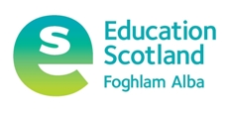

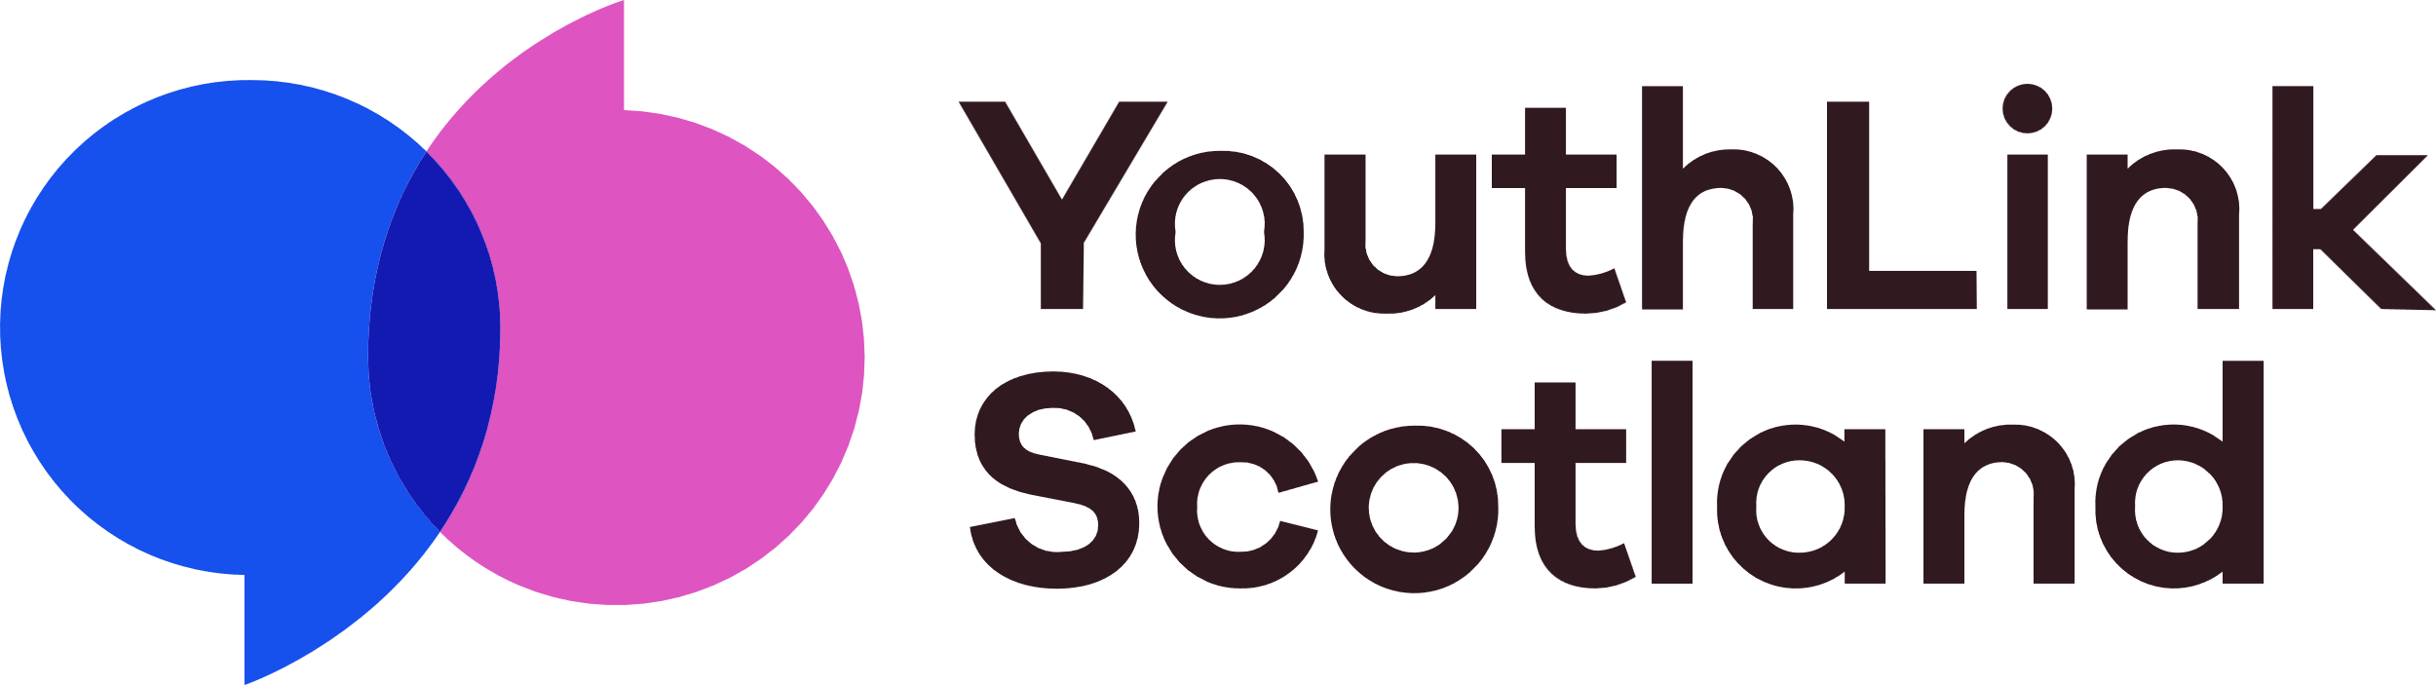

**A Collaborative Approach to Tracking Achievement: Toolkit**

The links below will take you to some useful resources and tools to support your conversations with members of your Tracking Achievement group in your learning community, and with young people. This toolkit accompanies the [resource](https://www.youthlink.scot/wp-content/uploads/A-Collaborative-Approach-to-Tracking-Achievement-.pdf) that describes each of the steps below in more detail. Please contact Gill at YouthLink Scotland for more information and support if you are piloting this process for the first time – [ggracie@youthlink.scot](mailto:ggracie@youthlink.scot) .

1. **Building a shared understanding of the value of a collaborative approach to tracking achievement**

* [Sample plan for the first meeting of the tracking achievement group](https://www.youthlink.scot/wp-content/uploads/Session-plan-1.docx)
* [Sample presentation for the first meeting of the tracking achievement group](https://www.youthlink.scot/wp-content/uploads/Setting-focus.pptx)
* [Lost in Translation resource](https://www.youthlink.scot/education-skills/scottish-attainment-challenge/boosting-attendance/#lost-in-translation)
* [A selection of case studies and short films about partnership working between youth work and schools](https://www.youthlink.scot/education-skills/scottish-attainment-challenge/#pupil-equity-funding)

1. **Introducing the National Youth Work Outcomes and Skills Framework to teachers and other partners.**

* [National Youth Work Outcomes and Skills Framework](https://www.youthlink.scot/education-skills/youth-work-outcomes-skills/)
* [Handout of skills and indicators](https://www.youthlink.scot/wp-content/uploads/Skills-and-indicators-handout.docx)
* [Worksheet to support focus-setting for individual programmes](https://www.youthlink.scot/wp-content/uploads/Setting-focus-worksheet.docx)
* [West Partnership animation created by Education Scotland – how the Framework helps to communicate quantitative and qualitative evidence of impact.](https://www.youthlink.scot/education-skills/scottish-attainment-challenge/understanding-impact/)

1. **Introducing the National Youth Work Outcomes and Skills Framework to young people**

* [Team exercise to explore skills](https://www.youthlink.scot/wp-content/uploads/Team-exercise-to-explore-skills.docx)
* [Handout of visual](https://www.youthlink.scot/wp-content/uploads/Handout-of-visual.pdf)

1. **Monitoring and evaluating progress**

* [Slides to support a discussion about how to monitor and evaluate progress with young people](https://www.youthlink.scot/wp-content/uploads/Evaluation-planning-presentation-final.pptx)
* [Sample observation sheet for practitioners](https://www.youthlink.scot/wp-content/uploads/Exemplar-Adult-Observation-Sheet-1.docx)
* [Sample discussion questions](https://www.youthlink.scot/wp-content/uploads/Skills-Discussion-Questions.docx)
* [Sample short check-in questions](https://www.youthlink.scot/wp-content/uploads/Skills-popcorn.docx)
* [Sample evaluation wheel](https://www.youthlink.scot/wp-content/uploads/Dundee-Youth-Work-Skills-Assessment-Wheels-Dec.pdf)

1. **Reporting on Progress**

* [Sample snapshot spreadsheet where youth workers / teachers can collate programme data.](https://www.youthlink.scot/wp-content/uploads/Collating-quantitative-and-qualitative-data.xlsx)